

A Project Report On

**“COURIER MANAGEMENT”**

**Submitted By:**

**Ganji Naveen**

Roll No: 99

CBSE ROLLNO:

Class: XII C

**Under the Guidance of**

Mr. Anoop V S

PGT (Computer Science)

Department of Computer Science

**SAINIK SCHOOL KALIKIRI**

**Department of Computer Science**

**SAINIK SCHOOL KALIKIRI**



This is to certify that **Cdt. Ganji Naveen,** Roll No. 99 of Class XII has prepared the report on the Project entitled **“COURIER MANAGEMENT”**. The report is the result of his efforts & endeavors. The report is found worthy of acceptance as final project report for the subject Computer Science of Class XII.

Signature Signature

(Internal Examiner) (External Examiner)



**DECLARATION**

I hereby declare that the project work entitled “**COURIER MANAGEMENT**”, submitted to Department of **Computer Science**, SAINIK SCHOOL KALIKIRI is **prepared** **by me**. All the **coding** is the result of my **personal efforts**.

Cdt. Ganji Naveen

Roll No: 99

Class: XII C

SAINIK SCHOOL KALIKIRI



**ACKNOWLEDGEMENT**

I would like to express a deep sense of thanks & gratitude to my **project guide Mr. Anoop V S** Sir for guiding me immensely through the course of the project. He always evinced keen interest in my work. His constructive advice & **constant motivation** have been responsible for the **successful** completion of this project.

My sincere thanks go to **Lt Col Susheel Kumar Mahapatro SM ,** our **Offg** **Principal** sir, for his co-ordination in extending every **possible support** for the completion of this project.

I also thanks to my **parents** for their **motivation & support**. I must thanks to my **classmates** for their timely help & support for **compilation** of this **project**.

**Last but not the least, I would like to thank all those who had helped directly or indirectly towards the completion of this project.**

Cdt. Ganji Naveen

Roll No: 99

Class: XII C

SAINIK SCHOOL KALIKIRI

**CONTENTS**

1. Working Description .........................
2. Code of the Project ............................
3. Output Screens …..............................
4. Bibliography .....................................

**1. WORKING DESCRIPTION**

**This program is created using python and mysql**

**1.run table.py file to create tables in database**

**2.run main.py to execute main program**

**2. Code of the Project**

**Note :** There are 5 Python files in this project.

**Main.py**

import mysql.connector as sql

conn=sql.connect(host= 'localhost' ,user= 'root' ,passwd= 'student', database='project' )

cust1=conn.cursor()

print('WELCOME TO COURIER SERVICE:')

print("Hi")

o=input('Press enter to begin your courier surfing')

print('1.CREATE YOUR COURIER SERVICE ACCOUNT')

print('2.LOGIN')

print('3.UPDATE PROFILE')

choose=int(input('ENTER (1) FOR NEW ACCOUNT OR (2) FOR LOGIN OR (3) FOR UPDATE:'))

if choose==1:

name=input('Enter your user-name:')

passwd=input('Set your password here:')

passwd1=input('Confirm password:')

cust1.execute("INSERT INTO user VALUES(' "+name+" ',' "+passwd+" ')")

conn.commit()

print('ACCOUNT CREATED CONGRATULATIONS')

move_in=input('press enter to login:')

import B_COURIER_MENU

elif choose==2:

user=input('Enter your username')

passd=input('Enter your PASSWORD:')

cust1.execute('select * from user where user_name = " '+user+' " and password = " '+passd+' " ')

if cust1.fetchone() is None:

print('sorry your password in wrong')

else:

import B_COURIER_MENU

elif choose==3:

name1=input("Enter your existing user name:")

passwd2=input('Enter your old password :')

cust1.execute('select * from user where user_name = " '+name1+' " and password = " '+passwd2+' " ')

data = cust1.fetchone()

if name1 == data[0].strip() and passwd2 == data[1].strip():

password = input("Enter your new password:")

password1 = input("Confirm your new password:")

if password == password1:

Query = f"update user set password ='{password1}'where user_name='{data[0]}'"

cust1.execute(Query)

conn.commit()

print("Password Successfully changed")

**B_COURIER_MENU**

import mysql.connector as sql

conn=sql.connect(host= 'localhost' ,user= 'root' ,passwd= 'student', database='project' )

cust1=conn.cursor()

for i in range(0,76):

print('WELCOME TO COURIER SERVICE:')

print('1.Courier_order and customer_details')

print('2.billing_procedure')

print('3.courier_service_boys')

print('4.exit')

choice=int(input('enter the section you want to access:....(1,2,3or4)........:'))

if choice==1:

print('For placing a courier do enter A')

print('To see order placed list do enter B')

print('enter c to cancel the order')

sect=str(input('enter the section that you want to access:'))

if sect=="A":

print('COURIER-ORDER')

a=(input('enter the customer name:'))

b=int(input('enter the customer mobile number:'))

c=(input('enter the customer address:'))

d=(input('enter the receiver name:'))

e=int(input('enter the receiver mobile number:'))

f=(input('enter the receiver address:'))

cust1.execute("INSERT INTO courier VALUES(' "+a+" ',"+str(b)+",' "+c+" ',' "+d+" ',"+str(e)+",' "+f+" ')")

conn.commit()

print(cust1.rowcount,'courier (s) placed')

print('===============================================================================================================')

elif sect=="B":

S=str(input('do you want to see your courier_order''(y \ n):'))

if S=="y":

a=input('enter the customer mob number:')

cust1.execute('select * from courier where customer_mobile_number="{}" '.format(a))

order=cust1.fetchall()

print('customer name,','customer mob no,','customer address,','receiver name,','receiver mob no,','receiver address:')

for j in order:

print(j)

print('===============================================================================================================')

elif sect=="c":

mob_no=int(input(('enter the mobile number to delete your order: ')))

cust1.execute(f"delete from courier where customer_mobile_number='{mob_no}'")

conn.commit()

print('Order successfully deleted')

else:

print('Thank you')

print('==============================================================================================================')

elif choice==2:

print('BILLING PROCEDURE:[weight_in_kgs......AND.......cost_in_rupees]')

cust1.execute("select * from couriers2")

bill=cust1.fetchall()

for x in bill:

print(x)

print('===============================================================================================================')

if choice==3:

city1=input('enter your city name:')

cust1.execute("select * from couriers3 where city='"+city1+"' ".format(city1))

boys = cust1.fetchall()

print(' City delivery_boy mobile no:')

for y in boys:

print(y)

print('===============================================================================================================')

elif choice==4:

quit()

B_COURIER_MENU.py

**BILLING PROCEDURE**

import mysql.connector as sql

conn=sql.connect(host= 'localhost' ,user= 'root' ,passwd= 'student', database='project' )

cust1=conn.cursor()

cust1.execute("insert into couriers2 values(' 1kg' ,' 50Rs' )")

cust1.execute("insert into couriers2 values('2kg','75Rs')")

cust1.execute("insert into couriers2 values('3kg','100Rs')")

cust1.execute("insert into couriers2 values('4kg','125Rs')")

cust1.execute("insert into couriers2 values('5kg','150Rs')")

cust1.execute("insert into couriers2 values('10kg','275Rs')")

cust1.execute("insert into couriers2 values('20kg','525Rs')")

cust1.execute("insert into couriers2 values('30kg','775Rs')")

cust1.execute("insert into couriers2 values('40kg','1025Rs')")

cust1.execute("insert into couriers2 values('50kg','1275Rs')")

cust1.execute("insert into couriers2 values('100kg','2520Rs')")

cust1.execute("insert into couriers2 values('150kg','3770Rs')")

cust1.execute("insert into couriers2 values('200kg','5020Rs')")

cust1.execute("insert into couriers2 values('250kg','6270Rs')")

cust1.execute("insert into couriers2 values('300kg','7520Rs')")

cust1.execute("insert into couriers2 values('350kg','8770Rs')")

cust1.execute("insert into couriers2 values('400kg','10020Rs')")

cust1.execute("insert into couriers2 values('450kg','11270Rs')")

cust1.execute("insert into couriers2 values('500kg','12520Rs')")

conn.commit()

**DELIVERY BOYS**

import mysql.connector as sql

conn=sql.connect(host= 'localhost' ,user= 'root' ,passwd= 'student', database='project' )

cust1=conn.cursor()

cust1.execute("insert into couriers3 values('kadapa','mohith','8328480609')")

cust1.execute("insert into couriers3 values('kalikiri','nani','9581207696')")

cust1.execute("insert into couriers3 values('kerala','amit','8666666666')")

cust1.execute("insert into couriers3 values('bengaluru','DJ','689742315')")

cust1.execute("insert into couriers3 values('kalikiri','naveen','200034272')")

conn.commit()

conn.close()

**TABLES**

import mysql.connector as sql

conn=sql.connect(host= 'localhost' ,user= 'root' ,passwd= 'student', database='project' )

cust1=conn.cursor()

cust1.execute('create table user(user_name varchar(99) ,password varchar(99))')

import mysql.connector as sql

conn=sql.connect(host= 'localhost' ,user= 'root' ,passwd= 'student', database='project' )

cust1=conn.cursor()

cust1.execute('create table courier(customer_name varchar(99) ,customer_mobile_number varchar(789),customer_address text(789),receiver_name varchar(99) ,receiver_mobile_number varchar(789),receiver_address text(789))')

import mysql.connector as sql

conn=sql.connect(host= 'localhost' ,user= 'root' ,passwd= 'student', database='project' )

cust1=conn.cursor()

cust1.execute('create table couriers2(Weight_in_kgs varchar(789),Cost_in_rupees varchar(789));')

import mysql.connector as sql

conn=sql.connect(host= 'localhost' ,user= 'root' ,passwd= 'student', database='project' )

cust1=conn.cursor()

cust1.execute('create table couriers3(city varchar(99),courier_boys varchar(99),courier_service_boys_mob_number varchar(99));')

**3.OUTPUT SCREENS**

**OPENING SCREEN**

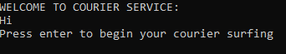

**PRESS ENTER**

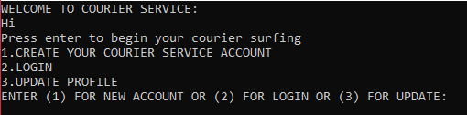

**ENTER 1 TO CREATE NEW ACCOUNT ,ENTER ASKED DETAILS**

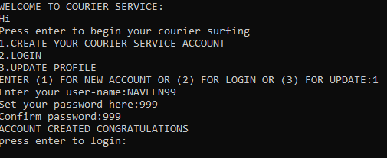

**PRESS ENTER TO LOGIN**

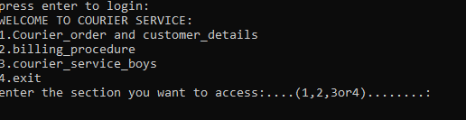

**PRESS 1 TO VIEW ORDER DETAILS**

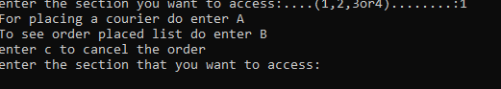

**SELECT A TO PLACE A NEW ORDER**

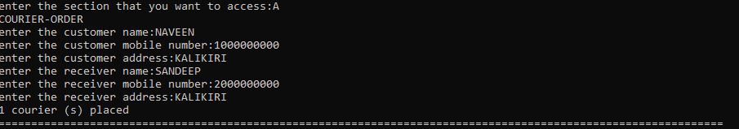

**ENTER 1 AND THEN SELECT B TO VIEW THE EXISTING ORDERS**

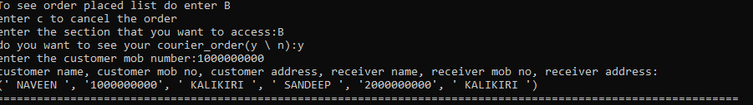

**ENTER 1 AND THEN SELECT C TO CANCEL ORDER**



**SELECT 2 TO VIEW BILLING PROCEDURE BASED ON WEIGHTS**

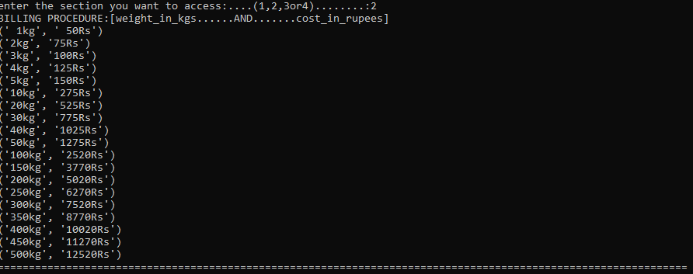

**ENTER 3 TO SEE DELIVERY PERSON’S DETAILS**

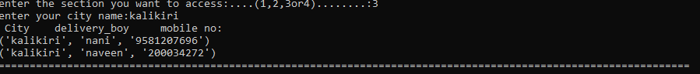

**ENTER 4 TO EXIT**

**ENTER (2) TO LOGIN**

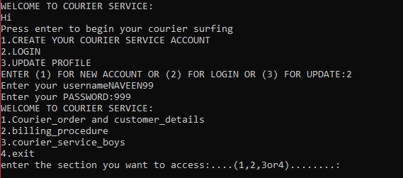

**ENTER (3) TO UPDATE YOUR PROFILE**

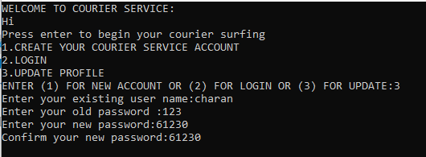

**4. BIBLIOGRAPHY**

1. Computer Science with Python [Textbook XII] by Sumita Arora